**Experiment 3**

**AIM:** Write a program which defines a class Bank with member functions deposit, withdraw, compound interest, and getBalance. It should have a constructor to initialize balance and rate of interest. Implement a menu driven program to use these features.

**Theory:**

A constructor is a member function of a class which initializes objects of a class. Destructor is a member function which destructs or deletes an object. There are 3 types of access modifiers available in C++:

1. **Public:** All the class members declared under public will be available to everyone.
2. **Private**: The class members declared as **private** can be accessed only by the functions inside the class.
3. **Protected**

**Code:**

1. #include < iostream >
2. #include < cmath >
3. using namespace std;
4. class Bank {
5. float balance, rate;
6. float getBalance() {
7. return balance;
8. }
9. float getRate() {
10. return rate;
11. }
12. float deposit(float m) {
13. balance += m;
14. return balance;
15. }
16. float withdraw(float m) {
17. if (balance >= m) balance -= m;
18. return balance;
19. }
20. float compound(int t) {
21. return balance * pow(1 + rate / 100, t);
22. }
23. public: Bank() {
24. cout << "Enter balance and rate:";
25. cin >> balance >> rate;
26. }~Bank() {
27. cout << "I am destroyed." << endl;
28. }
29. int menu() {
30. int op;
31. cout << "1 - Deposit" << endl;
32. cout << "2 - Withdraw" << endl;
33. cout << "3 - Compound interest" << endl;
34. cout << "4 - Get balance" << endl;
35. cout << "5 - Exit" << endl;
36. cin >> op;
37. switch (op) {
38. float money, time;
39. case 1:
40. cout << "Enter amount to deposit: ";
41. cin >> money;
42. cout << "Current balance: " << deposit(money) << endl;
43. break;
44. case 2:
45. cout << "Enter amount to withdraw: ";
46. cin >> money;
47. cout << "Current balance: " << withdraw(money) << endl;
48. break;
49. case 3:
50. cout << "Enter time: ";
51. cin >> time;
52. cout << "Compound interest: " << compound(time) << endl;
53. break;
54. case 4:
55. cout << "Current balance: " << getBalance() << endl;
56. break;
57. }
58. return op;
59. }
60. };
61. int main() {
62. Bank aneesh;
63. while (aneesh.menu() != 5) {}
64. return 0;
65. }

**Output**:

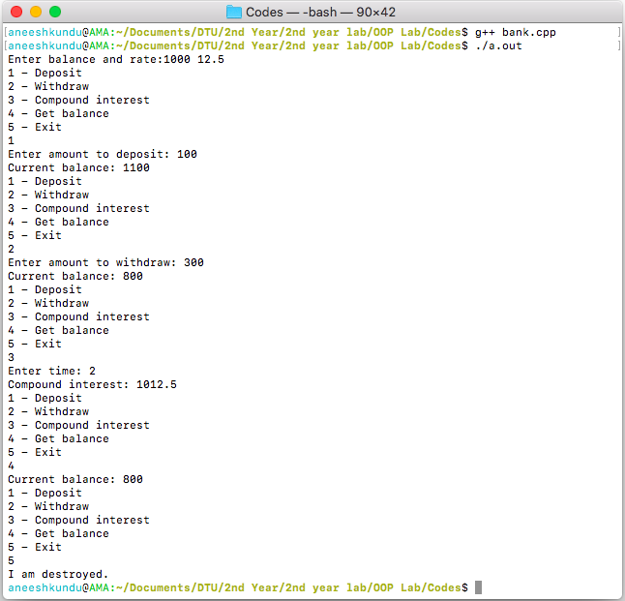

**Discussion:**

The class bank has 5 private methods: getBalance: to get the balance, getRate: to get the rate of interest, deposit: to deposit money and it returns the resultant balance, withdraw: to withdraw money and it returns the resultant balance, and compound to calculate compound interest. The constructor initializes the balance and the rate of interest. The menu method starts a menu driven program on the instance aneesh.